**CHANDIGARH UNIVERSITY**

**UNIVERSITY INSTITUTE OF ENGINEERING**

**DEPARTMENT OF COMPUTER SCIENCE AND ENGINEERING**



|  |  |
| --- | --- |
| **Submitted by:**  Yash Gupta 20BCS5009 | **Submitted To:**  Er. Bhupinder Singh (12856) |
| **Subject Name:** | Multimedia Technologies Lab |
| **Subject Code:** | 20CSP-339 |
| **Branch:** | CSE |
| **Semester:** | 5th |

LAB INDEX

|  |  |  |  |  |  |  |  |
| --- | --- | --- | --- | --- | --- | --- | --- |
| **Sr.No** | **Program** | **Date** | **Evaluation** | | | | **Sign** |
| **LW(12)** | **VV(8)** | **FW(10)** | **Total (30)** |
|  |  |  |  |  |  |  |  |
|  |  |  |  |  |  |  |  |
|  |  |  |  |  |  |  |  |
|  |  |  |  |  |  |  |  |
|  |  |  |  |  |  |  |  |
|  |  |  |  |  |  |  |  |
|  |  |  |  |  |  |  |  |
|  |  |  |  |  |  |  |  |

**Experiment 5**

**Student Name: Yash Gupta UID: 20BCS5009**

**Branch: BE-CSE Section/Group: 20BCS-MM-806 A**

**Semester: 5 Date of Performance: 29-09-2022**

**Subject Name: MMT LAB Subject Code:**

**Aim :-** Given a picture, make three copies of this picture. On one of these pictures, adjust the brightness and contrast, so that it gives an elegant look. On the second picture, change it to grayscale and the third is the original one using Adobe photoshop.

**Hardware Requirements: -** Minimum 384MB RAM, 100 GB hard Disk, processor with 2.1 MHz

**Software Requirements: -** Adobe Photoshop, Photopea

**Tools to be used:** Type Tool, Magic Wand, Lasso select

**Steps: -**

Step 1: Open Adobe Photoshop 7.0→ make 3 copies of the image file and import all the 3 images into it.

Step 2: Go to image 1 in the image menu bar, click on adjustments →select brightness or contrast→ increase or decrease.

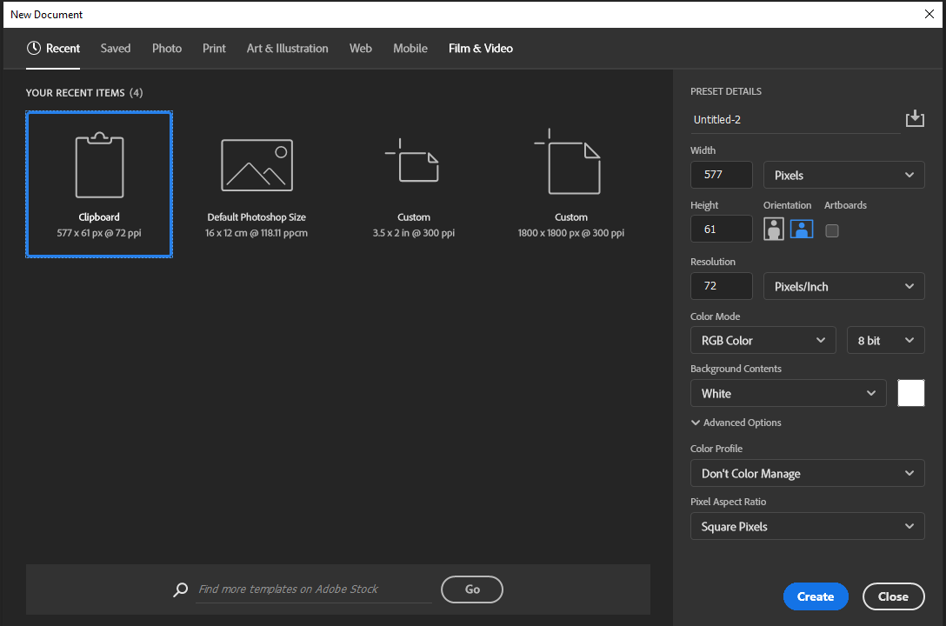

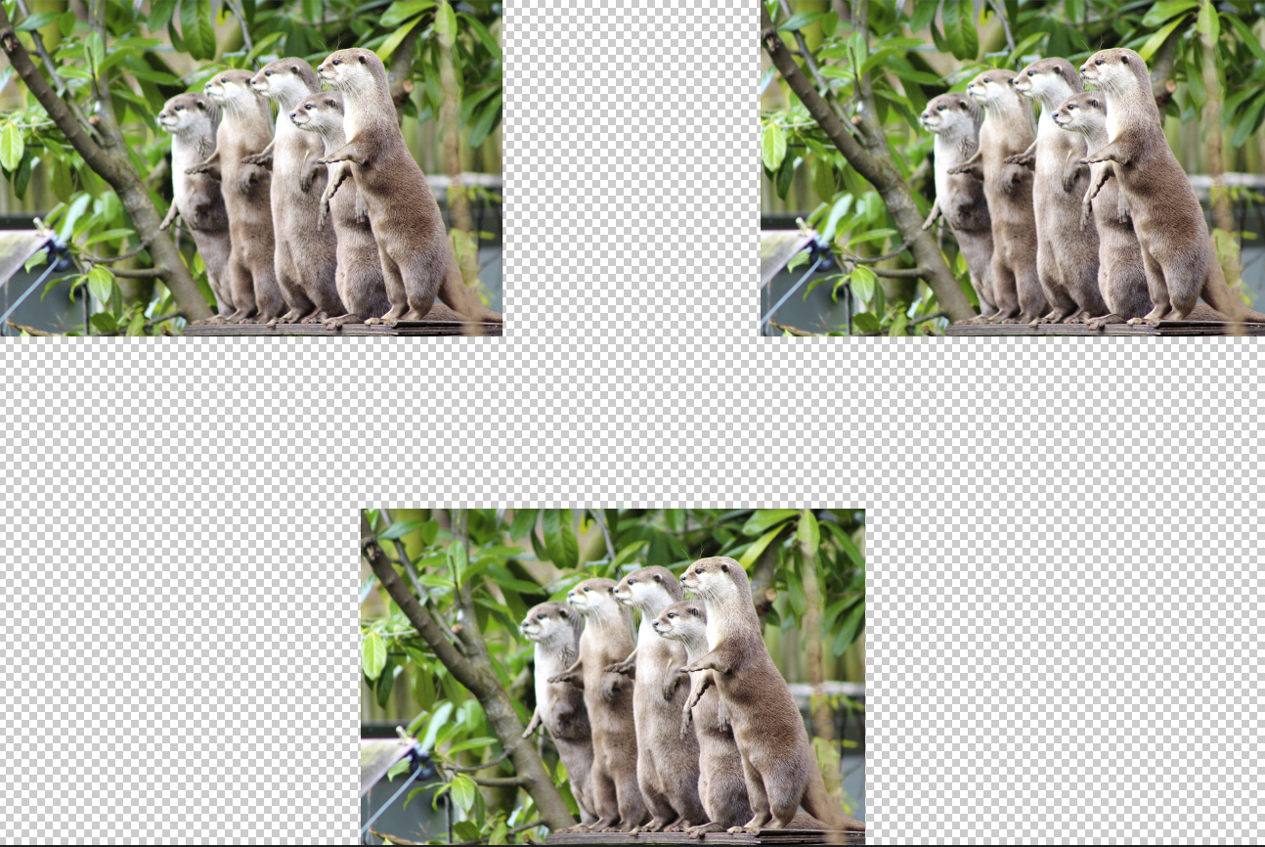

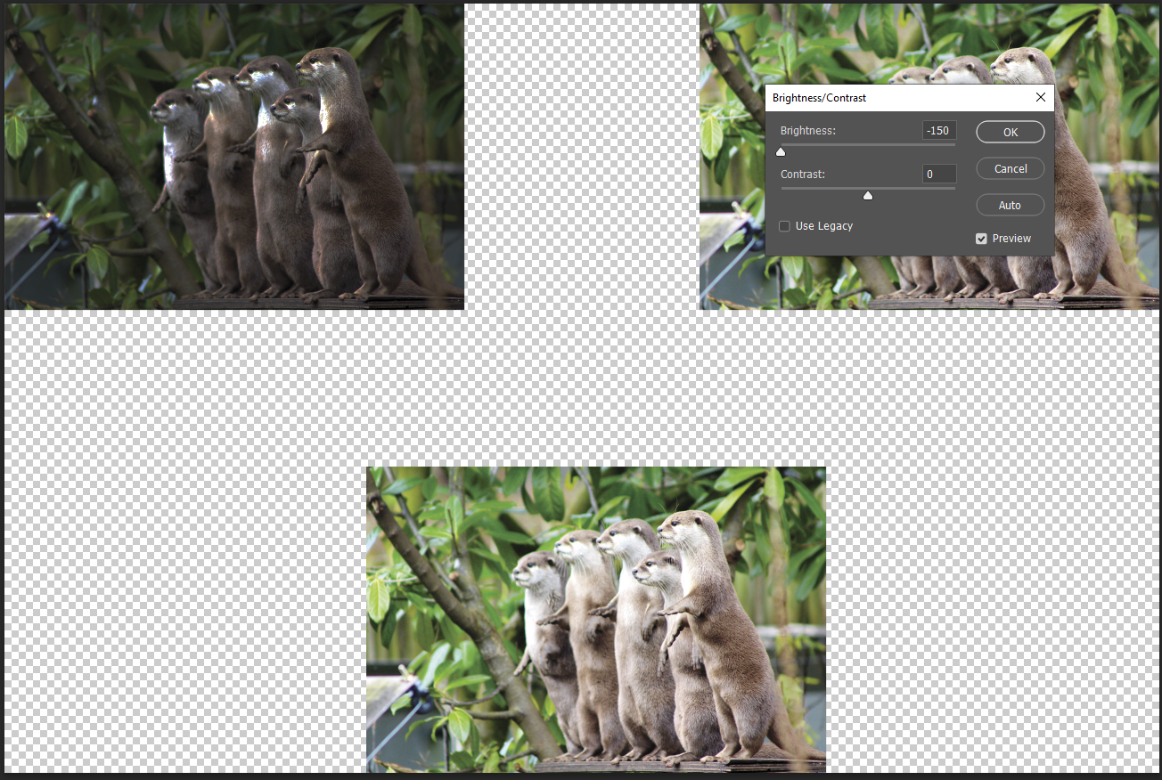

Step 3: Go to image 2, in the image menu→click on mode →select grayscale.

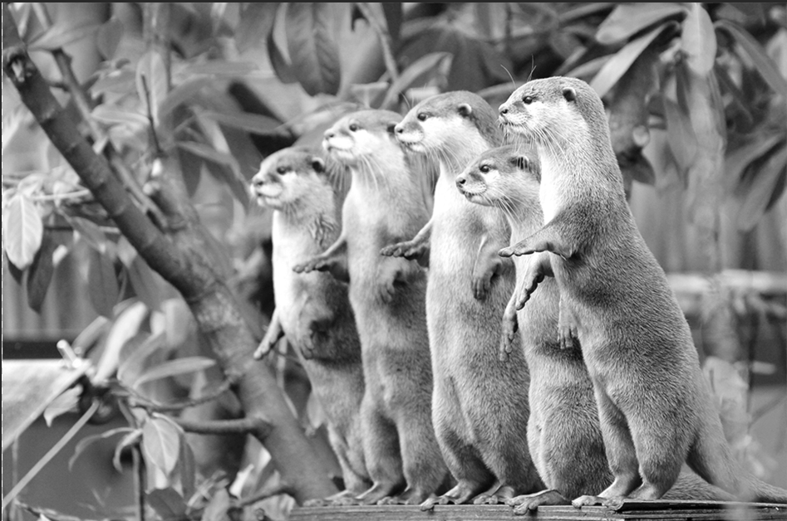

Step 4: Keep image 3 as the original.

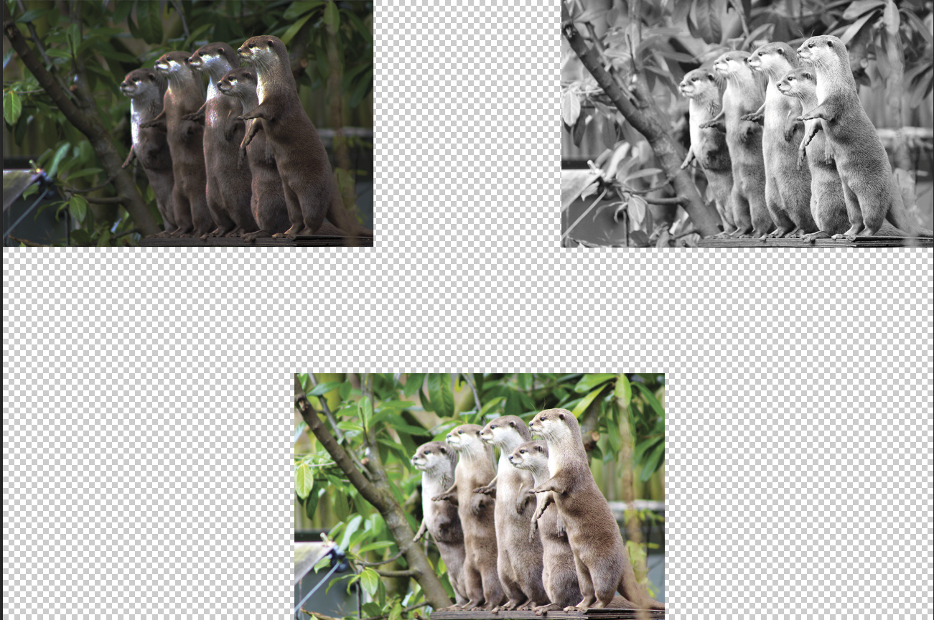

Step 5: Go to file→ new→ give height=10 and width=10 (inches)

Step 6: Copy all the 3 images into it.

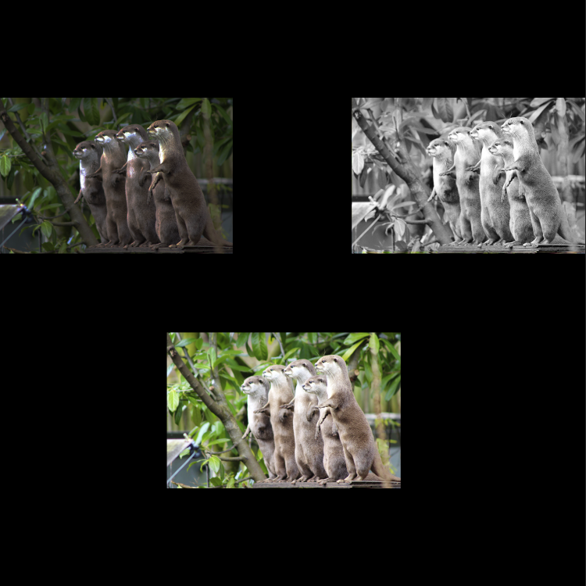

**Evaluation Grid (To be created as per the SOP and Assessment guidelines by the faculty):**

|  |  |  |  |
| --- | --- | --- | --- |
| Sr. No. | Parameters | Marks Obtained | Maximum Marks |
| 1. |  |  |  |
| 2. |  |  |  |
| 3. |  |  |  |